

|  |  |  |
| --- | --- | --- |
| **Course : (FSD101) -Web Programming I** | | |
| **Instructor: Kadeem Best** | **Date Given: January,19th 2020** | **Date Due: January, 23rd 2020** |

**Notes for the Student:** This Exercise is designed to give you practical experience in building a Simple Website using native HTML5 and CSS3.

**Background**: You will need to have access to an IDE or code editor and have a thorough understanding of HTML 5 and CSS3.

**Assignment Submission Requirements**

* An electronic copy of your work should be sent by 5:00PM on the deadline date.

**Explanation of the video:** <https://zoom.us/rec/share/55NbEeHCqTNLXI3f1V6PfrQjBt7aT6a80SQY-foInUloSAhxr2M0dkOnNT5-aJCy?startTime=1579411967000>

**Website Files :**

<https://drive.google.com/drive/folders/1_HGz2GfMBsUDjD8_AXc1rfR4GwFY6Vyx?usp=sharing>

**Font type of entire website** : Segoe UI

**Line height** : 1.7rem



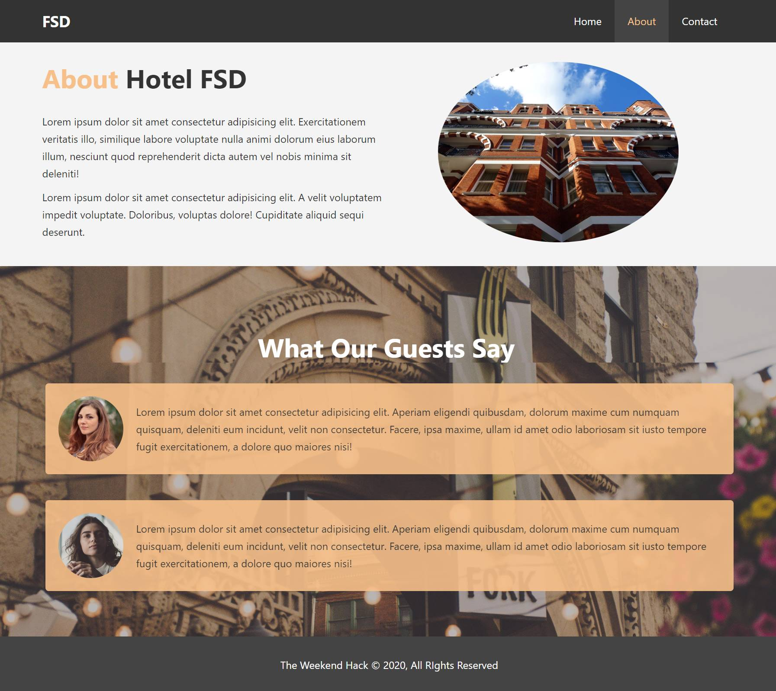

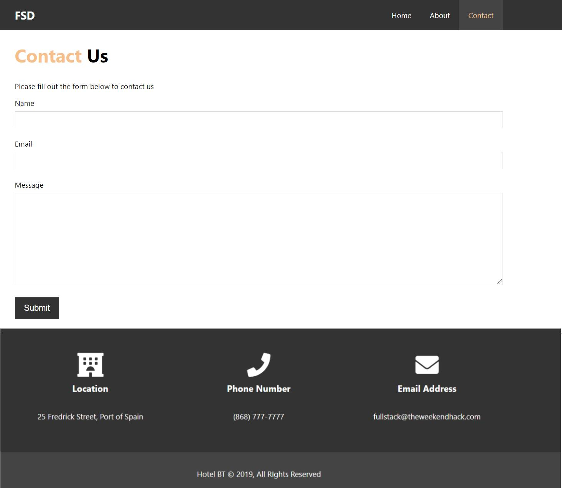

**THE END**